Playwright BDD Framework - Installation Guide
Repository:
https://github.com/kmrajashekar17/BDD_PlayWright_Framework

Important Note
This framework was developed and validated using the versions mentioned in this document.
Do NOT upgrade or downgrade:
- Node.js
- npm
- Java
- Playwright
- Cucumber
- TypeScript
- Allure packages
without performing complete regression testing.
Changing package versions may impact:
- Test execution
- Allure reporting
- GitHub Actions
- GitHub Pages publishing
- Screenshots
- Categories
- Trends
- Framework utilities

Step 1 - Install Git
Download:
https://git-scm.com/downloads
Verify:
git --version
where git
Expected:
git version 2.45.0.windows.1

Step 2 - Install Node.js
Install Node.js:
24.15.0
Download:
https://nodejs.org/dist/v24.15.0/
Ensure the following path exists in Environment Variables:
C:\Program Files\nodejs\
Verify:
node -v
npm -v
where node
where npm
Expected:
v24.15.0
11.16.0

Step 3 - Install Java
Install Java:
21.0.11 LTS
Configure:
JAVA_HOME=C:\Program Files\Java\jdk-21
Add to PATH:
%JAVA_HOME%\bin
Verify:
echo %JAVA_HOME%
java -version
javac -version
where java
Expected:
java version "21.0.11"
javac 21.0.11

Step 4 - Clone Repository
git clone https://github.com/kmrajashekar17/BDD_PlayWright_Framework.git

cd BDD_PlayWright_Framework

Step 5 - Install Framework Dependencies
npm ci
Verify:
npm list --depth=0
Expected packages:
@cucumber/cucumber 13.0.0
@playwright/test 1.61.1
@types/node 26.0.1
allure-commandline 2.43.0
allure-cucumberjs 3.10.2
allure-js-commons 3.10.2
dotenv 17.4.2
playwright 1.61.1
ts-node 10.9.2
typescript 5.9.2

Step 6 - Install Playwright Browser
npx playwright install chromium
Verify:
npx playwright --version
Expected:
Version 1.61.1

Step 7 - Verify Framework Setup
Execute:
git --version

node -v

npm -v

java -version

javac -version

npx playwright --version

npx cucumber-js --version

npx tsc -v

npx allure-commandline --version

npx tsc --noEmit

Expected:
Git : 2.45.0
Node.js : 24.15.0
npm : 11.16.0
Java : 21.0.11
Playwright : 1.61.1
Cucumber : 13.0.0
TypeScript : 5.9.2
Allure Commandline : 2.43.0

Step 8 - Execute Tests
Execute tagged tests:
npx cucumber-js --tags "@ValidateLogin"
Execute all tests:
npx cucumber-js

Step 9 - Generate and Open Allure Report
Generate and open latest report:
npm run report
Open any archived report:
npx allure-commandline open reports/archive/20260701_200739/allure-report
Open downloaded GitHub Actions report:
npx allure-commandline open C:\Users\hp\Downloads\allure-report

Recommended Installation Flow
1. Install Git
2. Install Node.js 24.15.0
3. Configure Node.js PATH
4. Install Java 21.0.11 LTS
5. Configure JAVA_HOME
6. Configure Java PATH
7. Clone Repository
8. Execute npm ci
9. Execute npx playwright install chromium
10. Execute npx tsc --noEmit
11. Execute tests
12. Execute npm run report
After completing the above steps, the framework is ready for execution.

Additional Command line (CMD) Verification
Command | Expected
where node | C:\Program Files\nodejs\node.exe
where npm | C:\Program Files\nodejs\npm C:\Program Files\nodejs\npm.cmd C:\Program Files\nodejs\node_modules\npm\bin\npm C:\ProgramFiles\nodejs\node_modules\npm\bin\npm.cmd C:\Users\hp\AppData\Roaming\npm\npm C:\Users\hp\AppData\Roaming\npm\npm.cmd
where java | C:\Program Files\Common Files\Oracle\Java\javapath\java.exe C:\Program Files\Java\jdk-21.0.11\bin\java.exe
java -version | java version "21.0.11" 2026-04-21 LTS
javac -version | javac 21.0.11
echo %JAVA_HOME% | C:\Program Files\Java\jdk-21.0.11
where git | C:\Program Files\Git\cmd\git.exe
git --version | git version 2.45.0.windows.1

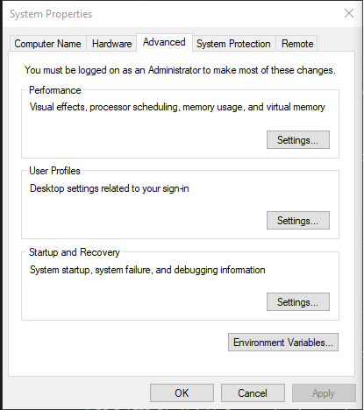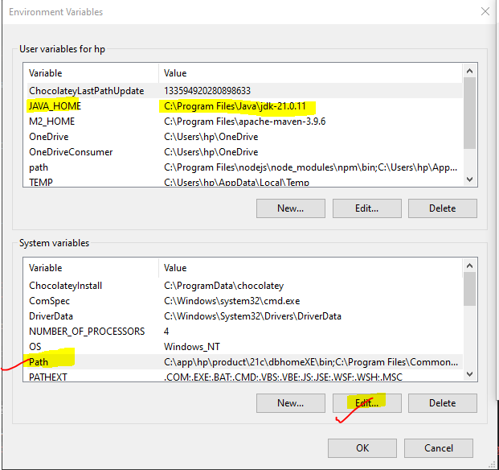
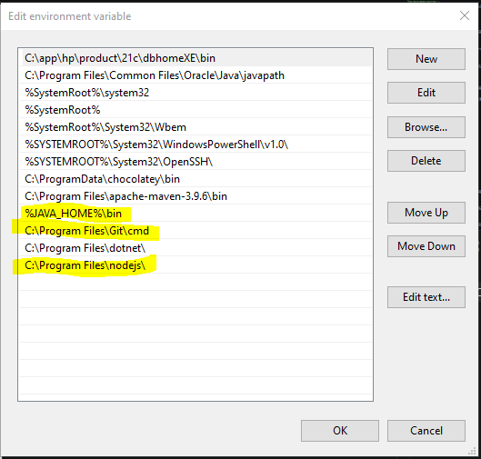

Let's break down what's happening in the CustomWorld.ts file.
This file is a core part of integrating Cucumber with Playwright. It allows you to create a shared context for each test scenario, making it possible to pass objects like the browser page or API request context between different steps in a. feature file.

What is the "World" in Cucumber?
In Cucumber, the "World" is an object that provides a unique, isolated context for each scenario. Before a scenario starts, a new World instance is created. This instance is then passed to all hooks (Before, After) and step definitions for that specific scenario. When the scenario finishes, the World instance is destroyed.
This ensures that data from one scenario doesn't leak into another, preventing test flakiness.

What is CustomWorld.ts doing?
The default World object in Cucumber is empty. The CustomWorld.ts file defines a custom class that extends the default World and adds properties that are specific to your testing framework.

In this file:
export class CustomWorld extends World implements IWorld: We are defining a new class named CustomWorld that inherits from Cucumber's base World class.
Properties: We are adding properties to this class that will hold state during a scenario's execution:
context!: BrowserContext;: This will hold the Playwright browser context.
page!: Page;: This will hold the active browser page for UI tests.
pages!: PageManager;: This will hold an instance of your PageManager factory, which gives you access to all your Page Objects.
apiRequest!: APIRequestContext;: This will hold the context for making API requests in your API tests.
The ! after each property name is a "definite assignment assertion" in TypeScript. It tells the compiler that even though these properties aren't initialized in the constructor, they will definitely be assigned a value before they are ever used (which happens in your hooks/Hooks.ts file).

What is setWorldConstructor(CustomWorld) doing?
This is the final and most crucial part. The setWorldConstructor function is provided by Cucumber. You call it to tell Cucumber: "Hey, instead of using your default, empty World object for each scenario, I want you to use my CustomWorld class instead."

How It All Connects
Cucumber sees setWorldConstructor(CustomWorld).
When a new scenario starts, Cucumber creates a new instance of CustomWorld.
Your Before hook in hooks/Hooks.ts runs. The this inside the hook refers to the CustomWorld instance for that scenario.
Inside the hook, you initialize the properties: this.page, this.context, this.pages, and this.apiRequest are all created and assigned.
Your step definitions (e.g., in LoginSteps.ts) run. The this in each step also refers to that same CustomWorld instance.
This is why you can do this.pages.get(LoginPage).enterUserName(...) inside a step. You are accessing the pages property that was set on the CustomWorld instance during the Before hook.
When the scenario ends, the After hook runs, and then the entire CustomWorld instance is discarded.
In short, CustomWorld.ts defines a blueprint for a scenario's context, and setWorldConstructor tells Cucumber to use that blueprint. This is a clean and standard pattern for managing state within BDD tests.

